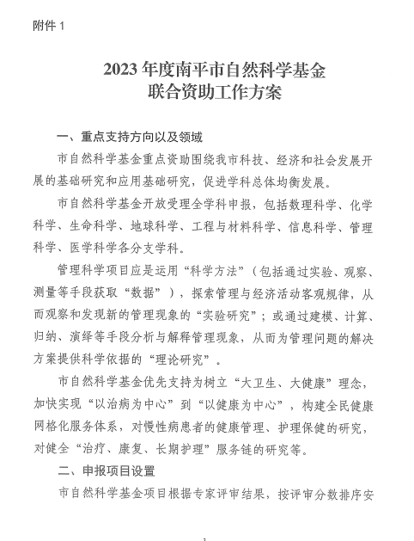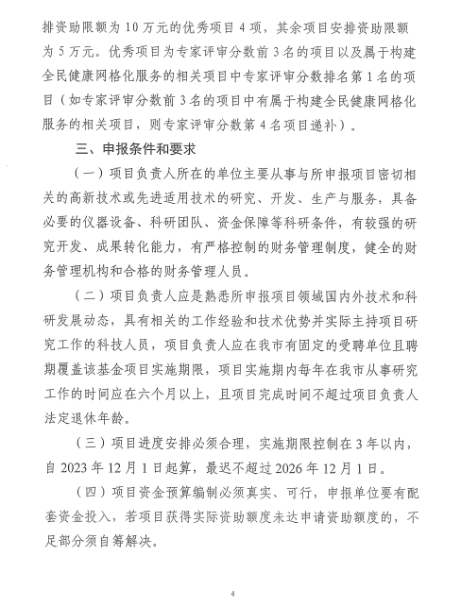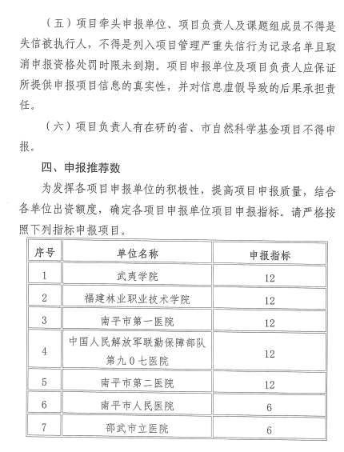

附件2

**2023年度南平市自然科学基金联合资助项目申报汇总表**

 推荐单位（公章）：

|  |  |  |  |  |  |
| --- | --- | --- | --- | --- | --- |
| 序 号 | 项目名称 | 承担部门 | 项目负责人 | 联系电话 | 备 注 |
| 1 |  |  |  |  |  |
| 2 |  |  |  |  |  |
| 3 |  |  |  |  |  |
| 4 |  |  |  |  |  |
| 5 |  |  |  |  |  |
| 6 |  |  |  |  |  |
| 7 |  |  |  |  |  |
| 8 |  |  |  |  |  |
| 9 |  |  |  |  |  |
| 10 |  |  |  |  |  |
| 11 |  |  |  |  |  |
| 12 |  |  |  |  |  |
| 13 |  |  |  |  |  |
|  |  |  |  |  |  |
|  |  |  |  |  |  |
|  |  |  |  |  |  |

|  |
| --- |
|  |